Name: Korada Vijaya Anjali

Roll No: 21A91A6148

Email: [anjalikorada1008@gmail.com](mailto:anjalikorada1008@gmail.com)

College: Aditya Engineering College, Surampalem

Task: Week-4

1. Troubleshoot network connectivity between an EC2 instance and an RDS database instance within the same VPC.
2. Use AWS VPC Flow Logs to identify and resolve connectivity issues between the instances.

* Launch the VPC with public and private subnets, Routing tables, Internet gateway, NAT gateway.
* It was done in week 3 task.
* Go to AWS RDS to create the database. Create and launch the RDS. For this 1st we need to create a SUBNET GROUP. In RDS we find this subnet group.

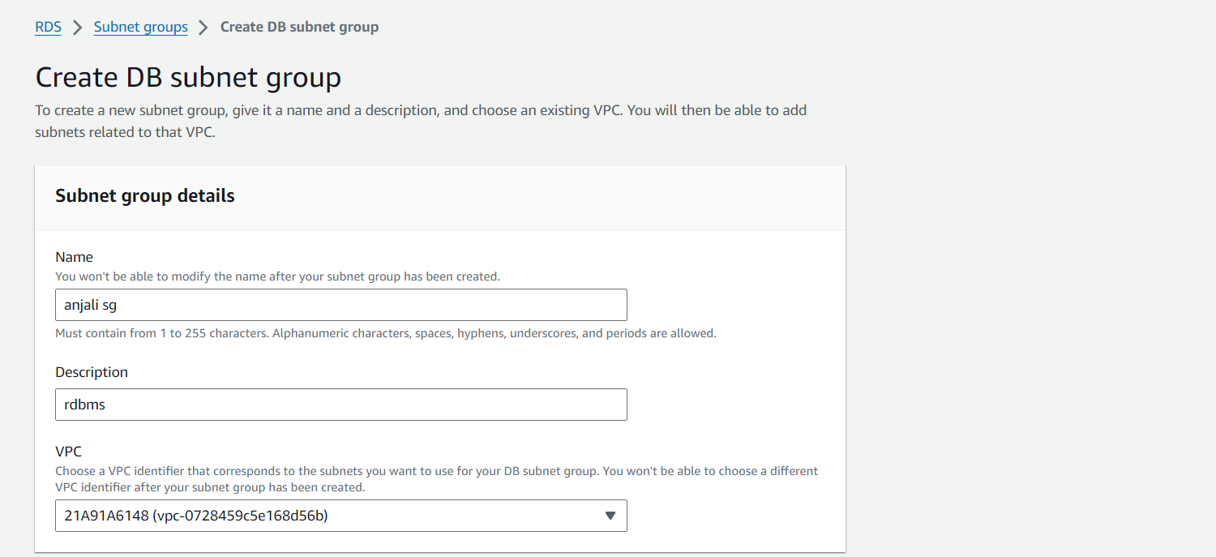

* Create a db subnet group.

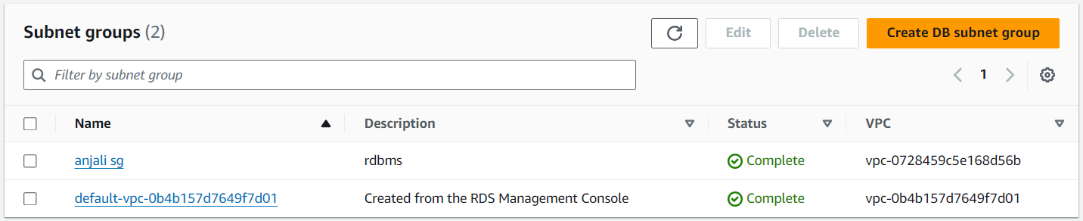

* Create a database sql while creating read the options twice and choose the appropriate ones for our database

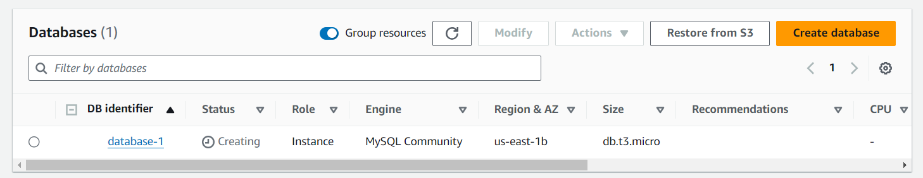

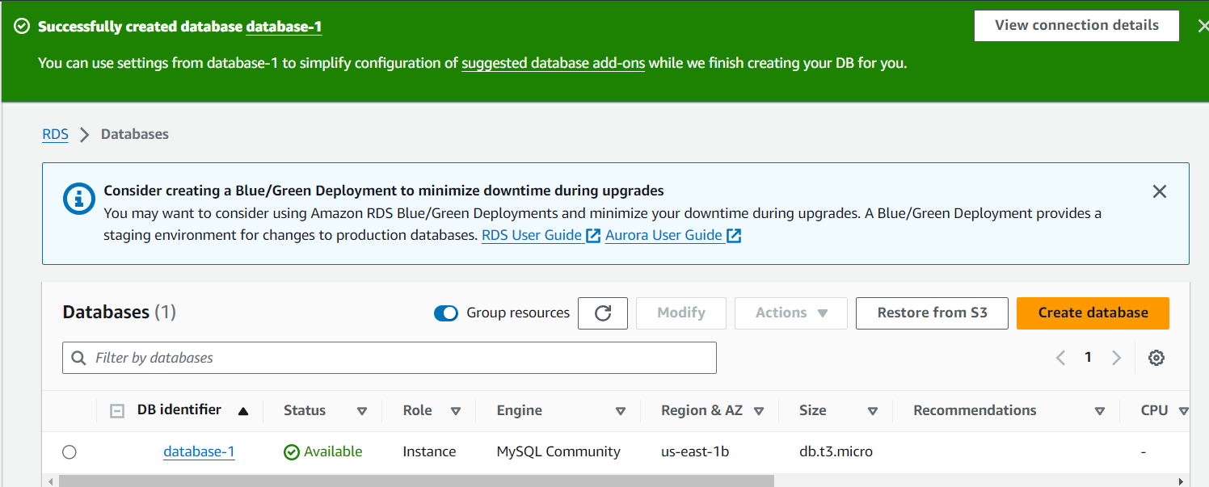

* Now launch a EC2 instance.

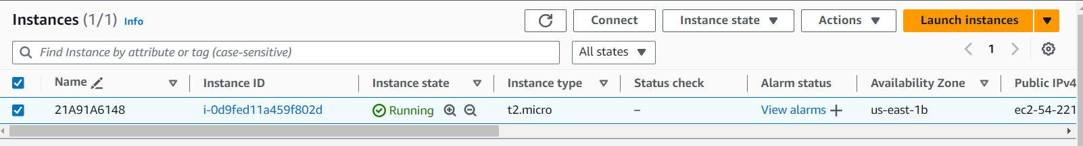

* Create sg for ec2 and database connection

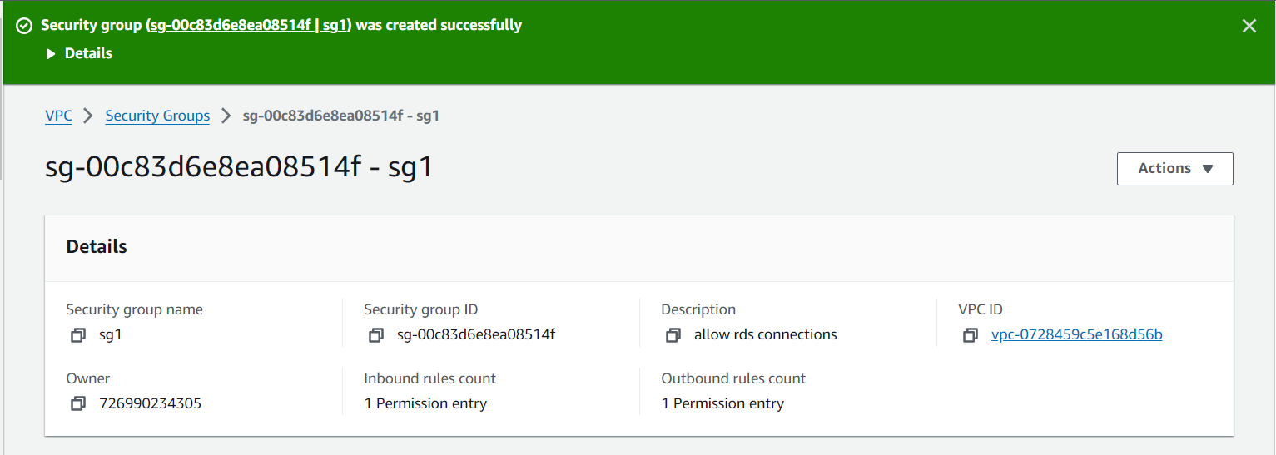

* Set up the rds connection to ec2 we created by using actions-> connection to ec2 -> choose the ec2 you want to connect.

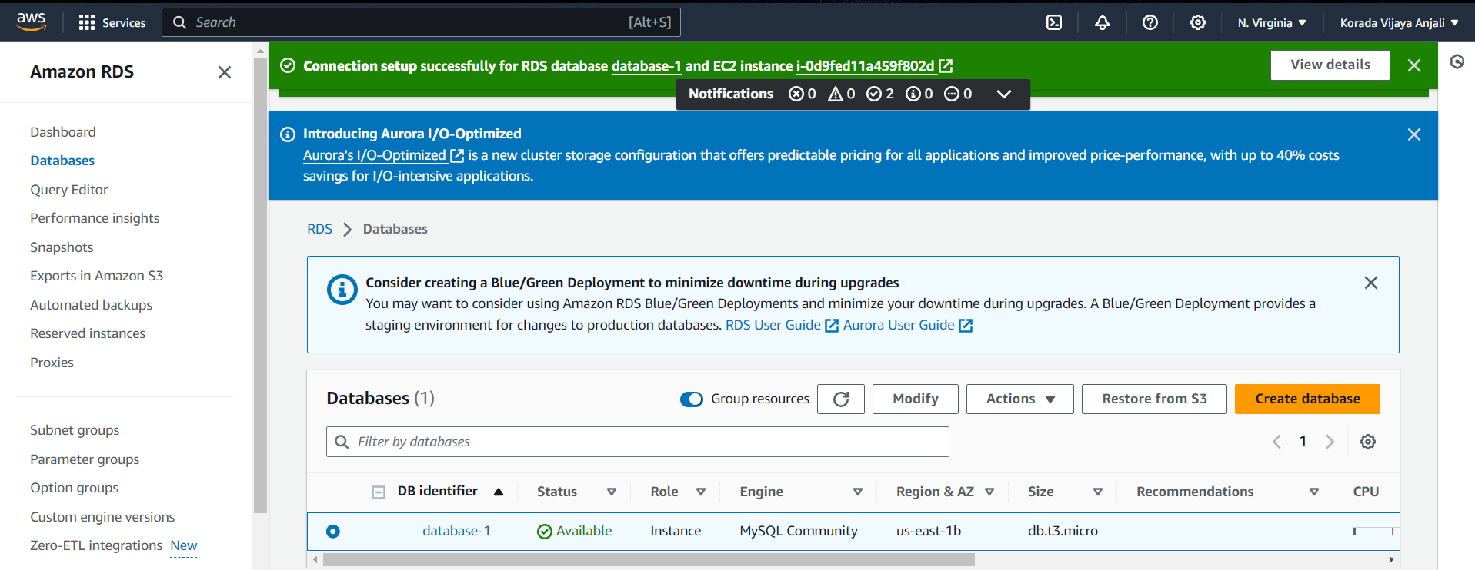

* Connect the ec2 instance using mobaxterm.

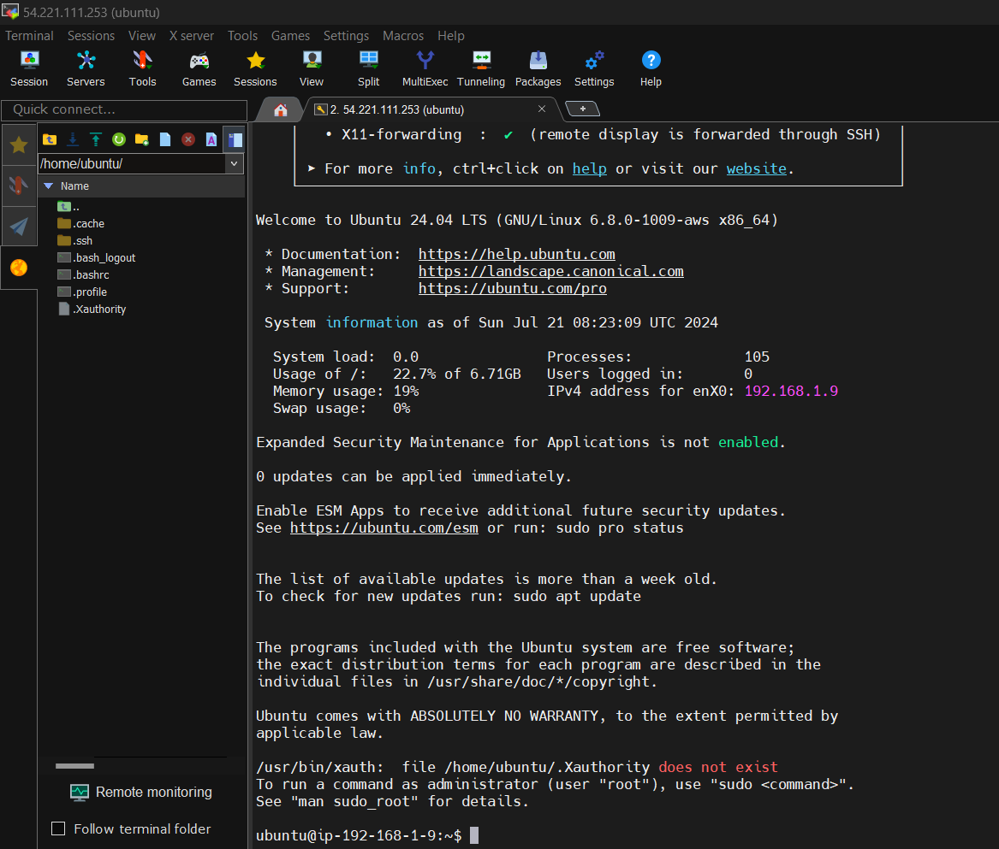

* Use the commands in ec2 instance

1. sudo su
2. apt-get update –y
3. apt-get install mysql-client –y
4. sudo mysql –u admin –p –h (end point of dbms)
5. Then you enter into the database you created

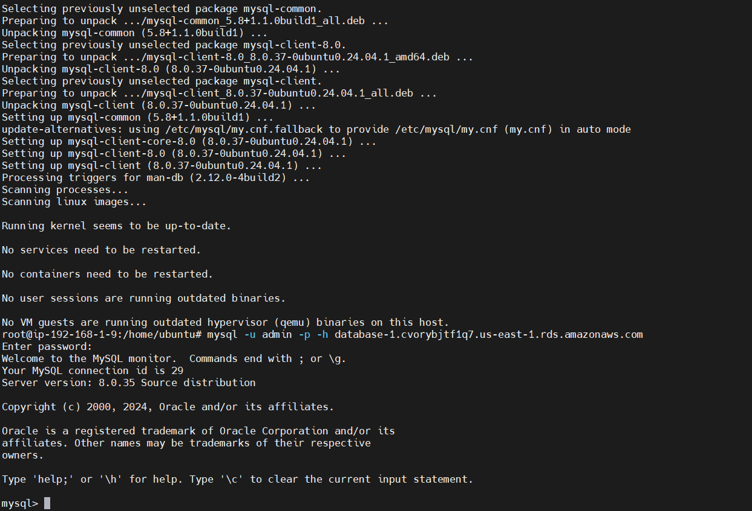

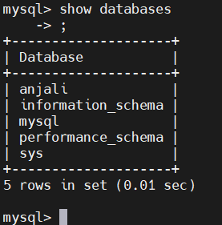

* This is how we connect database in ec2 instace

rt

rds

Private subnet

Public subnet

igw

internet

Ec2 (bation host)

**SUMMARY:**

* Create a VPC.
* Create a 2 subnets (public and private).
* Make one subnet as public by enable the ipv4.
* Create a routing table and associate the 2 subnets.
* Create a internet gateway and attach it with VPC the add its routes to rt.
* Create a NAT gateway and add its routes to RT but is shows errors so create another RT and then associate it with private subnet add the routes then.
* Here we created a VPC correctly.
* Now create a RDS before create a DB subnet group for creating RDS now create it. (here we face some issues with VPC like DHCP solve them by enabling it, create a security group also).
* Create a ec2 instance.
* Now attach the database we created with ec2 in RDS.
* Create a security group by allowing the routes of database here select the sg you created.
* Now your database and ec2 are connected.
* Now connect the ec2 with mobaxterm.
* Using the above commands connect with database we enter into the database now we can work with it.